Shabbos Stories for
Parshas yisro 5783
Volume 14, Issue 22 – 20 Shevat 5783/February 11, 2023
Printed L’illuy nishmas Nechama bas R’ Noach, a”h

For a free subscription, please forward your request to keren18@juno.com
Past emails can be found on the website – ShabbosStories.com

The Power of Reciting Birkat Hamazon from a Bentcher

Menachem Zeckbach, z”l

Rabbi Yoel Gold told a story about a sofer—scribe who had an incredible experience with Hashgacha Peratit—Divine Providence. Shortly after the stampede tragedy in Meron, Chaim Ganz, the sofer, took it upon himself to visit some of the people that had lost family members at the event, because he had recently lost his five-year-old daughter and wanted to give them some nechama—comfort.
The first family he went to visit happened to be his neighbors, the Zeckbach family, who lost their young son Menachem. He was a 24-year-old kollel boy who was recently married. When Chaim got to the house, he saw Birkat Hamazon cards on the table, and printed on them were the words: “The last will of Menachem Asher Zeckbach was to pray Birkat Hamazon out of a bentcher.”

A Commitment to Never Wash for Bread
Unless He Had a Birkat Hamazon Card
He asked the family, “How could such a young boy have a will?” His family explained that Menachem took this upon himself eight years before, and he was so meticulous about it, he never ever washed without knowing he had a Birkat Hamazon card available. Chaim was amazed, he went there to give chizuk—strength, and he ended up leaving strengthened. He decided to take on this mitzvah in memory of Menachem.
Fast forward a few weeks later. Chaim was currently trying to find sofer opportunities, but every time he gave publishers a sample of his scribing, they told him it’s nice, but there’s something missing in his writing style. Dejected from all the rejection, he stopped in Bnei Brak at a bakery and bought a bagel for lunch. He went to the apartment that was provided for community sofrim to write.
He washed, ate, and quickly realized he didn’t have a Birkat Hamazon card or siddur. He looked all through the apartment to find one, and finally found a card printed in sofer scribing. The writing and symbols were a vintage style and really interesting. After he prayed, inspired, he rewrote a page from his book sample and copied the letters from this Birkat Hamazon card. He spent hours copying them over.

Offered a Project to Write a Sofer Torah
Not even five minutes after he finished, another sofer knocked on the door and entered the apartment. He saw Chaim there and said, “I was offered a project, but I’m swamped; I can’t do it. Do you want it?”
Chaim said, “Of course, I’ve been looking for a new project!”
The friend said, “Okay, but they need a sample of your work. Do you happen to have anything on you that I could give them today?”
Amazed, Chaim handed over the freshly completed page, and his friend said he would go drop it off and let him know soon.
Half an hour later, the friend called Chaim, “I’m here with the family and they’re absolutely blown away from your writing. They want to hire you to write a Sefer Torah.” Chaim was ecstatic! He said, “I’m in! What is this for?”
His friend said, “There’s a rabbi in Boro Park, Rav Shmuel Dovid Friedman. He wants to help the families whose loved ones passed away in Meron. Every family who lost someone will get a Sefer Torah in their memory. You’ll be writing one for the Zeckbach family, in memory of Menachem Asher Zeckbach.”
It was unbelievable! The whole story came full circle! It is written in the Sefer HaChinuch, “Anyone who is careful with saying Birkat Hamazon, will have his needs provided with honor and dignity.” Let’s all take a few minutes a day to say Birkat Hamazon with concentration to help instill our sense of gratitude, and to help remember that Hashem is in control.

Reprinted from the Parshas Bo 5783 email of Jack E. Rahmey as based on the Torah teachings of Rabbi Amram Sananes.

How to Treat Someone
Who Mistreats You
By Rabbi Mordechai Levin

A story once occurred with Reb Yisroel Salanter, ZT”L, (1810-1883) which illustrated his sterling character, and why he was recognized as a leader of the Mussar movement. He once took a train from Kovno to Vilna, dressed inconspicuously as a simple Jew.
Seated next to him was a young, married Yid who unfortunately didn’t have one nice thing to say. He bothered Reb Yisroel about various minor things throughout the trip. At one point he yelled at Reb Yisroel for opening the window. Reb Yisroel politely explained that he had not opened it, even as he got up to close it. When the train reached Vilna, a large crowd greeted and paid homage to the great Reb Yisroel Salanter.

Terribly Upset When He
Realized Who He Had Mistreated
When the Jew realized that the person he had hassled on the train was, in fact, Reb Yisroel Salanter, he was terribly upset and couldn’t sleep all night. The next morning, he went to Reb Yisroel to ask for forgiveness. Before he could begin, a smiling Reb Yisroel greeted him warmly and asked if he had recovered from the trip.
The Jew burst into tears and asked for forgiveness. Reb Yisroel told him not to worry, and that he should just learn from his mistake to better treat others in the future. Reb Yisroel inquired into his business, and learned that he was in town to get rabbinical approval to become a shoichet (ritual slaughterer). Reb Yisroel immediately introduced him to his son-in-law Reb Eliyahu Eliezer, ZT”L, and asked him to help the Yid.
Reb Eliyahu Eliyahu reported back to Reb Yisroel that the Yid knew very little about the laws of slaughtering an animal! Reb Yisroel hired a veteran shoichet to teach the Yid, and a while later the Yid became an expert shoichet. Reb Yisroel kept in constant contact with him until he found him a job as a shoichet in a respectable town. This was the manner that the great Reb Yisroel responded to someone who had treated him badly.

Reprinted from the Parshas Bo 5783 email of Torah Sweets

A Chicken in Every Pot

Mrs. Epstein was waiting in line at the butcher shop, and when at last her turn came two youngsters entered the store. "You won't mind waiting a few more minutes, will you, Mrs. Epstein?" the butcher asked. "I'll be done with these kids in a moment."
She did mind, as she was very tired, but didn't say anything. She watched as the butcher proceeded to gather up chicken legs, gizzards, necks and other leftover parts, weigh the entire mess and scoop it all into a bag. He handed the bag to the children, and the older of the two said, "Please put it on our account."
Mrs. Epstein was appalled. Didn't the butcher earn enough without having to charge obviously needy people for the garbage he would have discarded? Too weary to engage in a heated discussion, she allowed the issue to pass...until the following week, when precisely the same incident transpired. "How can you do such a thing?" Mrs. Epstein demanded of the butcher.
"I'll tell you," the butcher replied. "Their mother had been a good customer for many years, when suddenly her husband fell ill. He couldn't pay his bills, mine included, but I couldn't allow a family with nine children to starve, could I? I carried them for month after month, until their account stretched back over three years. It was a tidy sum, and I couldn't afford to carry them much longer. So I started saving all the trimmings that would normally be discarded, and I'd give it to them for Shabbat. Each week, they tell me to put it on their account, and each week I...don't. Oh, sure I weigh it and make a show of entering the amount in my book, but only to maintain their dignity."

Tears of Pity for the Needy Family
Tears welled up in Mrs. Epstein's eyes - tears of pity for the needy family and tears of shame for misjudging the kindly butcher. She opened her purse and pulled out her checkbook. "I want you to send two chickens to them at once," she said, "not only today, but every Friday. But you must never reveal my identity to them." The butcher happily complied, and knowing Mrs. Epstein was a woman of very modest means herself, charged her well below the wholesale price.
But the story doesn't end here. When Mrs. Epstein related her tale to a friend, that friend also withdrew her checkbook, anxious to participate in this beautiful misvah. "It's funny you should do that," Mrs. Epstein said, "because this story actually took place a number of years ago, and everyone to whom I've related it has reacted in an identical fashion. Baruch Hashem, I now have nineteen families whom I supply with Shabbat chickens, and countless anonymous people who generously share my misvah with me. And all because of my failure to judge my fellow man favorably!

The Importance of Judging Others Positively
All too often, failures like Mrs. Epstein's do not have such positive results. Our Sages have affirmed that the way one judges his fellow man is the way G-d will judge him. This, along with the fact that it is a positive commandment from the Torah, should be sufficient incentive to judge others favorably. Inevitably, observance of this misvah also makes for a happier life. (A Midrash and a Ma'aseh)

Reprinted from the Parshat Bo 5783 email of Rabbi David Bibi’s Shabbat Shalom from Cyberspace.
Incident in a Book Store
in Meah Shearim in Jerusalem

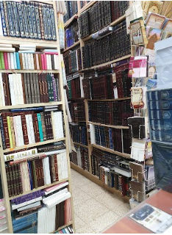

A man, who we’ll call Reuven, was shopping for sefarim in a book store in Meah Shearim. He picked up a sefer and started flipping through it. Then he noticed, out of the corner of his eye, that a man (who we’ll call Shimon) was facing him from the other side of the store, and appeared to be staring at him. Reuven looked into the sefer and tried to ignore him, but he began to feel uncomfortable.
A few moments later, Reuven felt a tap on his shoulder. He looked up and saw Shimon standing right in front of him, with that same staring look. Shimon said, “Excuse me, but are you planning on buying this sefer?
Reuven was a bit startled, and said, “Yes. Do you have a problem with that?”
Shimon said, “Please forgive me. I don’t want to be nosy, but if you are planning on buying it, please let me pay for it.”
This caught Reuven by surprise. “Why would you want to do that? he asked.
Simon answered, “I am blind. I will never again be able to study Torah from the sefarim that meant so much to me. I want to pay for your sefer so that you will learn from it as much as possible. When your eyes become tired and you are ready to close the sefer, please think of me and keep it open a little longer.”
Reuven eyes began to tear, and he accepted Shimon’s offer. The storekeeper later confirmed that Shimon would routinely do this a few times a week to various customers. This was his way of continuing to learn Torah. Reuven resolved that he would not put that sefer down lightly. When he would be tired, he would push himself to learn a little more.
After a while, this attitude spread to his other learning as well. He had a new appreciation of his ability to see, and the value of learning from a sefer took on a new meaning for him.

Reprinted from the files of the Jersey Shore Torah Bulletin.

Switching the Shiur
(Class) to English

At one of the Shabbos meals at an Agudah convention, Rabbi Shlomo Soroka, the director of government affairs at the Agudah of Illinois, introduced his Rebbi, Rav Elya Brudny, Shlit”a, with a story.
He had been a Talmid in Rav Brudny’s Shiur in the Mirrer Yeshivah in Brooklyn, and as is typical in many Yeshivos, the Shiur was given in Yiddish. However, one day Rav Brudny suddenly switched the language of the Shiur to English, which surprised the Talmidim, and some of them even protested.
The next day, some Bochurim organized an official letter asking Rav Brudny to resume giving the Shiur in Yiddish, which was passed around to all the boys in the Shiur for them to sign. When the letter reached Shlomo Soroka for his signature, he was stunned that this was being done. He reprimanded the organizers and said, “Rebbi didn’t forget how to speak Yiddish. If he decided to switch to English, he must have had a good reason for it,” and the matter was put aside.
Rabbi Soroka then explained to the convention that in fact, he knew there was a Bochur in the Shiur who had been struggling to keep up with the Shiur, precisely because it was delivered in Yiddish. When Rav Brudny found out this, he called over the Bochur and told him that he would be switching the Shiur to be in English.

From left to right: Rabbi Shlomo Soroka and Rav Elya Brudny

Rav Brudny explained, “By me, Yiddish is a Hiddur Mitzvah, but it’s not the only way it has to be. If a Talmid will only be able to grasp the Shiur if it’s in English, then that will be the language it will be delivered in.”
“I know this story,” Rabbi Soroka said, “because I was that Bochur!”

Reprinted from the Parshas Va’era 5783 email of Rabbi Yehuda Winzelberg’s Torah U’Tefilah.

Rav Aryeh Levin’s “Great” Yeshiva Accommodations

When Rav Aryeh Levin, zt”l, was a young man, he learned in the Yeshivah in Slutzk under the great Rosh Yeshivah, Rav Isser Zalman Meltzer, zt”l. At that time, life was extremely difficult for European Jewry, and the Yeshivah Bochrim tended to suffer the most. In order to help them, a program was started where the Bochrim were sent to different homes in the community to eat their daily meals, even though, in many cases, there wasn’t even enough food for the families themselves.
In this way, the Yeshivah Bochrim learned Torah with purity, despite the deprivation, and the greatness of Torah learning during that period produced some of the greatest Roshei Yeshivos and Tzadikim in recent history.
Many years later, when Rav Aryeh had grown and married, he became a neighbor of Rav Isser Zalman in Yerushalayim. As Rav Isser Zalman talked with Rav Aryeh about his time in the Yeshivah in Slutsk, he innocently asked, “And where did you have your lodgings?”

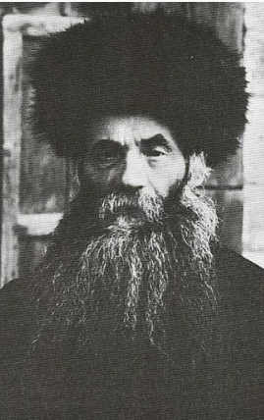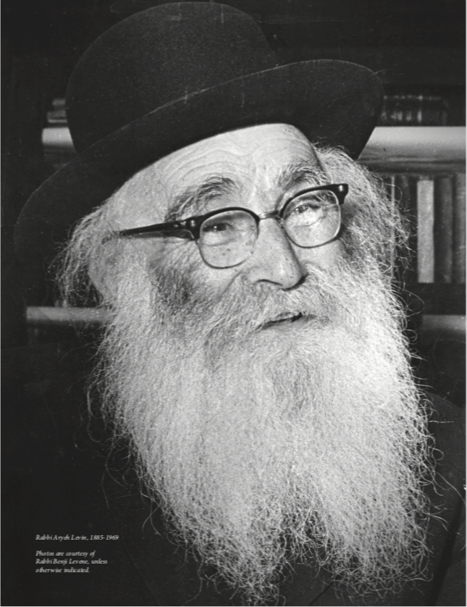
From let to right: Rabbi Isser Zalman Meltzer and Rabbi Aryeh Levin

Rav Aryeh replied, “I was quite comfortable. I had a bench in the one of the local Shuls as my regular place to sleep.”
Rav Isser Zalman was not very pleased with this answer. He inquired, “And where did you eat?”
Rav Aryeh smiled. He said, “I had very good accommodations. On Sundays I went to one family, on Tuesdays I went to another family, and on Thursdays, I went to a different family,” naming the three families in Slutzk that helped provide for him.
Rav Isser Zalman looked surprised. “But what about the other days?”
Rav Aryeh replied, “Baruch Hashem, I managed very well.” Rav Isser Zalman realized that as a young student, there were days that Rav Aryeh had gone without eating. Rav Isser Zalman was overcome with distress and pain.
“Please forgive me for my lack of awareness,” he said with true emotion. Rav Aryeh was taken aback at his Rosh Yeshivah’s reaction and assured him that he had neither suffered nor felt any neglect. He said that he had no memories of being deprived, and he calmed his Rosh Yeshivah as best he could.
Late that night, Rebbetzin Meltzer came knocking at Rav Aryeh Levine’s door. Rav Aryeh and his family were surprised to see the distinguished Rebbetzin there so late at night. “Please come at once,” she requested urgently of Rav Aryeh. “My husband, the Rosh Yeshivah must see you.”

Afraid of His Day of Judgment
Rav Isser Zalman was not able to sleep. Rav Aryeh found his Rebbi sitting up, with tears running down his cheeks. He said, “What will I answer on my day of judgment, when they ask me how it was that I never knew that Rav Aryeh Levine slept on a bench with no proper bed, that he did not have enough food to eat, and he learned Torah in hardship and suffering? What will I answer when they ask me why I did nothing to help him?”
He continued to cry until finally, Rav Aryeh was able to reassure him that he wholeheartedly did not mind the situation he had in Yeshivah, and in fact, he was happy and thankful that he was able to learn under such conditions, as that had made him become exactly who he was now!

Reprinted from the Parshas Va’era 5783 email of Rabbi Yehuda Winzelberg’s Torah U’Tefilah.

The Rebbe and the Innkeeper

Yankel the innkeeper lived in an isolated hamlet for so long that he hardly remembered that he was a Jew. Shabbat was a word he hardly recalled. Day and night he served the Polish peasants who bought drinks in his little inn. Nothing new ever happened and one year slipped unnoticed into the next.
One day, however, a stately-looking Jew entered Yankel’s inn and disturbed Yankel’s quiet existence. This visitor was none other than the famous tzadik, Rabbi Moshe Leib of Sassov, who had leased a hut in the middle of a forest in order to meditate and pray in the stillness of the woods.
At times, however, he came to the inn to purchase food, and that is how he came to know Yankel. When the tzadik had first entered his inn, something deep inside Yankel stirred and prompted him to say to the rabbi, “You know, Sir, I too, am a Jew.”
“How can you live in a place where there are no other Jews?” the tzadik queried him. “Why, it seems you have even forgotten our holy traditions. My poor brother, why, even the animals of Jews refrain from work on the Shabbat. Can you do even less than that?”

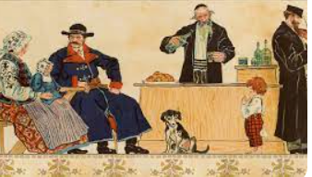

Yankel blushed at Rabbi Moshe Leib’s words. “But, Rabbi,” he continued, “I have to stay open on Shabbat or the peasants buy their drinks elsewhere, and I will be destitute!”
“Nevertheless,” Rabbi Moshe Leib insisted, “you must close on Shabbat. How can a holy Jewish soul do less than the donkey of a Jew who is kept from working on the Sabbath day?”
When Yankel saw that the tzadik was adamant, he began to think and he resolved to close the inn on Shabbat. Yankel’s announcement provoked a bitter reaction from his customers. “If you refuse to sell us liquor, we’ll...we’ll... complain to the landlord! He’ll throw you out! You can’t do this to us!”
Yankel knew they were as good as their words – particularly when it touched the issue of vodka. He walked deep into the forest until he found the hut of the tzadik. “The peasants are threatening to ruin me,” Yankel cried.
“Don’t worry. Bolt the doors. If the landlord questions you, do not hesitate to tell him that your G-d commanded Jews to keep the Sabbath day holy,” replied Rabbi Moshe Leib.
The innkeeper was very frightened, but he resolved to do as the tzadik said. Shabbat arrived and Yankel bolted the door of his inn. The peasants arrived and began to pound on the door and windows trying to get in. Finally, the voice of the landlord could be heard outside, demanding that Yankel open up the inn.
Yankel had no choice but to open, and it was a very angry poritz who entered the inn crying, “Who do you think you are, denying vodka to your customers!? Why else did I lease this inn, except to make a profit?”
“Sire,” began a frightened Yankel, “surely you know I am a Jew. Just recently I was told by a holy Jew that our Torah forbids us to work on the Sabbath day. That is why I have closed the inn today.”

The Landowner’s Curiosity
The directness of the reply intrigued the landowner. “Where is this person? Bring him to me!”
Soon, Rabbi Moshe Leib was standing before the landlord.
“Tell me, Jew, does this prohibition against working apply to a Jew who is in danger of losing his livelihood?” he asked, in a cutting tone.
“Sire, it applies even in such a case,” was the tzadik’s reply.
“Why do you torment this man? I doubt your answer would be the same if it applied to you. I will find out, and if you are really sincere, I will permit the inn to close on the Sabbath.”
The landlord left, a plan hatching in his mind. The following Shabbat, the landowner rode into the forest with a bag of gold coins. When he saw Rabbi Moshe Leib leaving his hut, he scattered the coins on the floor of the forest and waited to see what would transpire. At first the tzadik passed right by the coins, but then he returned and examined them closely. The landlord waited gleefully for the fatal moment when the Jew would eagerly scoop them into his hands. But no, he continued walking.

Explain Your Interest in the Money?
The landowner then rushed out of his hiding place. “I am very impressed, and I will keep my end of the deal. But tell me, why did you first ignore the money and then bend down to examine it?”
“I will explain,” began Rabbi Moshe Leib. “At first, I ignored the money, for it was Shabbat. But then, I began to think how I needed the money to rescue many imprisoned Jews. Perhaps that mitzva overrides the prohibitions of the Shabbat. I became confused, and then I prayed to G-d to give me direction. Suddenly I understood. G-d could certainly provide me with the money in a permissible way.
Sire, if I had taken or hidden the money, you would not have understood my motives. You would have assumed that I was taking it for my own desires. I have always scrupulously observed the Shabbat, and now Heaven has protected me from coming to any harm. Surely, now you can see the importance of keeping the holiness of the Sabbath.”

Reprinted from the Parshat Vaera 5783 edition of L’Chaim
Mattan Torah – The
Giving of the Torah
By Rabbi Nachman Zakon

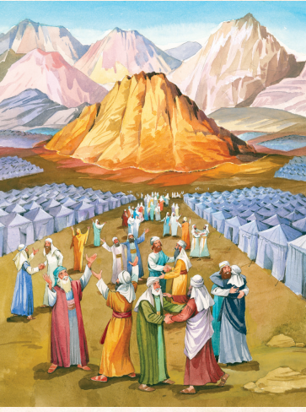
Illustratred by Tova Katz

The most important day in world history is the day the Torah was given! If the Jews hadn’t accepted the Torah, the world would have disappeared. That makes it the greatest thing that ever happened.
The reason the world exists, the reason it was created, and the reason it still exists, is for people to keep the Torah. Nothing in the world is as great and valuable as our Torah.
The Torah is important for another reason too. Without it we wouldn’t know how to use the world the way Hashem wants us to. We wouldn’t know how we’re supposed to act, how to behave to others, how to make Hashem — and ourselves — happy.
This parashah describes the preparations the Jews made to receive the Torah, and what happened on the day the Torah was given. The story begins on Rosh Chodesh Sivan, the day the Jews arrived at Har Sinai. This was the mountain where Hashem had spoken to Moshe from the burning bush, telling him it was time to take the Jews out of Egypt.

Reprinted from the Parshas Yisro 5783 edition of the At the ArtScroll Shabbos Table. Excerpted from “The Weekly Parshah: An Illustrated Retelling of the Chumash with Midrash – Sefer Shemos.

Why Aren’t You
The Cohen Family?

A young woman came to the Chazon Ish, terribly distressed. She had been involved with shidduchim for a long time and had met many young men, but nothing had worked.
“Am I so terrible?” she cried to the gadol hador. “Am I so lacking that no one wants me?”
The Chazon Ish responded softly, “Let me ask you a question. If you were asked to deliver a letter to the Cohen family on Rechov Rabbi Akiva 2, and when you arrived there you found that Rechov Rabbi Akiva 2 is an apartment building with no names on any of the doors, what would you do?”
The young woman was taken aback by the question, but after thinking for a moment, she said, “I would knock on the first door I encountered on the first floor.”
“Correct,” replied the Chazon Ish. “And if the person opening the door told you, ‘No, we are not the Cohens. We are the Yitzchakis. The Cohens lives upstairs on the third floor’ — what would you say? Would you respond angrily, ‘What do you mean you’re not Cohen? A chutzpah! You should be Cohen!’
“Of course you would not respond that way, because you know that you can’t expect Cohen to be found in Yitzchaki’s apartment. “The same is with shidduchim. Each time a shidduch does not work, it’s not a reflection on you. It simply means that you met ‘Yitzchaki’ when you were looking for ‘Cohen.’ “I assure you that when you will finally meet ‘Cohen,’ things will fall into place very quickly” (related by the Chazon Ish’s talmid Rav Ben Zion Fellman).
Reprinted from the Parshas Yisro 5783 edition of the At the ArtScroll Shabbos Table. Excerpted from “Rav Chaim Kanievsky on Shidduchim” by Naftali Weinberger.

